SPECIALS!!!  New Patients  2 Sessions for $75  Includes: *Consultation  *Measurements  *Meal Planning  *1 Follow up Session  4 Sessions for $145  Includes: *Consultation  *Measurements  *Meal Planning  *3 Follow up Sessions  12 Sessions for $360  Includes: *Consultation  *Measurements  *Meal Planning  *11 Follow up Sessions  - BODY AND MIND WEIGHT LOSS  - by norma borrego  - call for appointments: (915)328-8030 or (915)626-5531 |  | 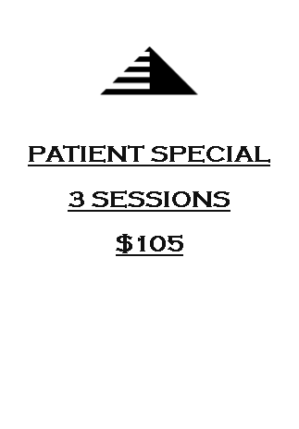  “This one step – choosing a goal and sticking to it – changes everything.”  -Scott Reed  WE DON’T  ACCEPT  MEDICAL  INSURANCE  NO REFUNDS  NO HAY  DEVOLUCIONES  Gift cards  available

